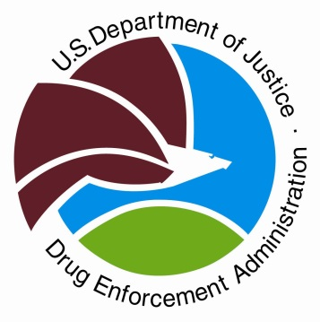

Drug Enforcement Administration
Administrator Terrance Cole
www.dea.gov
@DEAHQ

December 3, 2025
Contact: DEA Media Affairs
571-776-2508
For Immediate Release
NEWS RELEASE
DEA Launches Fentanyl Free America Initiative to Combat the Synthetic Drug Crisis

WASHINGTON – The U.S. Drug Enforcement Administration is intensifying its fight against the deadly threat of synthetic opioids with the launch of Fentanyl Free America, a comprehensive enforcement initiative and public awareness campaign aimed at reducing both the supply and demand for fentanyl. This effort underscores DEA's unwavering commitment to protecting American lives and communities from the devastating impacts of fentanyl, which claimed nearly 50,000 lives last year according to the Centers for Disease Control and Prevention (CDC).

Through intensified enforcement operations and heightened intelligence, DEA is applying unprecedented pressure on the global fentanyl supply chain, forcing narco-terrorists, like the Sinaloa Cartel and CJNG Cartel, to change their business practices. This has led to encouraging signs of progress. DEA laboratory testing indicates 29% of fentanyl pills analyzed during fiscal year (FY) 2025 contained a potentially lethal dose, a significant drop from 76% of pills tested just two years prior in FY 2023. Additionally, fentanyl powder purity decreased to 10.3%, down from 19.5% during the same time period. These reductions in potency and purity correlate with a decline in synthetic opioid deaths to levels not seen since April 2020.

Aside from producing less potent fentanyl, the cartels have increasingly diversified their operations in an attempt to minimize their risks and maximize profits, an evolution driven by opportunity and greed.

As of December 1, 2025, DEA has seized more than 45 million fentanyl pills, and more than 9,000 pounds of fentanyl powder, removing an estimated 347 million potentially deadly doses of fentanyl from our communities. DEA intelligence indicates a shift in cartel operations, with increased trafficking of fentanyl powder and domestic production of fentanyl pills. The seizure of more than two dozen pill press machines in October further highlights this trend.

"Fentanyl Free America represents DEA’s unwavering commitment to save American lives and end the fentanyl crisis, we are making significant progress in this fight, and we must continue to intensify efforts to disrupt the fentanyl supply and reduce demand,” said DEA Administrator Terrance Cole. “DEA is striking harder and evolving faster to dismantle the foreign terrorists fueling this crisis, while empowering all our partners to join the fight to prevent fentanyl-related tragedies. Together, we can achieve a fentanyl free America and create a safer future for generations to come.”

DEA remains at the forefront of the fight to disrupt trafficking networks and strengthen the government’s response to this epidemic. Fentanyl Free America represents DEA’s heightened focus on enforcement, education, public awareness, and strategic partnerships. The goal of the campaign is clear: eliminate the fentanyl supply fueling the nation’s deadliest drug crisis. Since 2021, synthetic opioids have claimed nearly 325,000 American lives.

The Fentanyl Free America campaign also emphasizes the importance of public engagement. DEA encourages everyone from community leaders, clergy, educators, parents, physicians, pharmacists, and law enforcement to take an active role in raising awareness by protecting others through education; preventing fentanyl overdoses by understanding the dangers; and supporting those impacted. Free resources including posters, radio advertising, billboards, and social media resources are available at dea.gov/fentanylfree.

DEA’s efforts are part of a larger whole-of-government strategy to dismantle transnational criminal organizations and protect U.S. communities from fentanyl.

# # #

